

[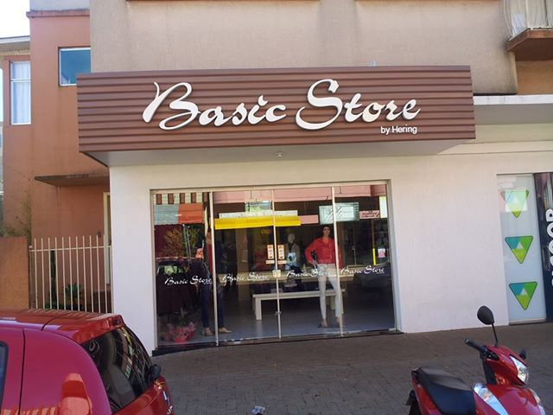](https://www.facebook.com/photo.php?fbid=220224394803031&set=a.129874690504669.28321.129162210575917&type=1&relevant_count=1)

[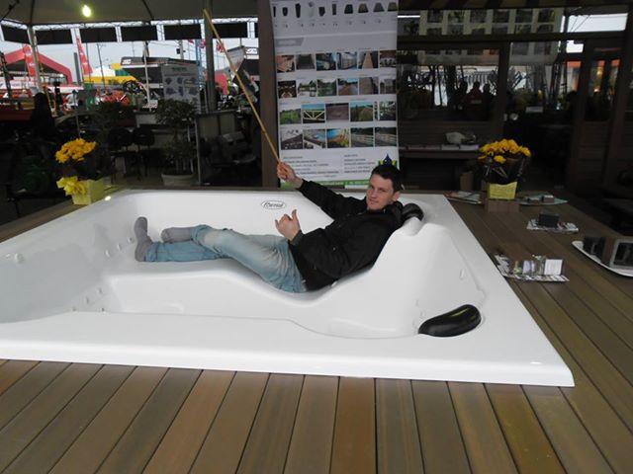](https://www.facebook.com/photo.php?fbid=219506571541480&set=a.129874690504669.28321.129162210575917&type=1&relevant_count=1)



[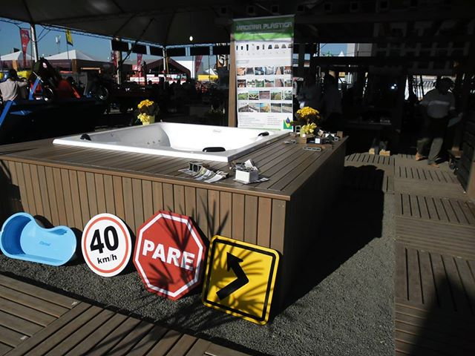](https://www.facebook.com/photo.php?fbid=219505344874936&set=a.129874690504669.28321.129162210575917&type=1&relevant_count=1)

[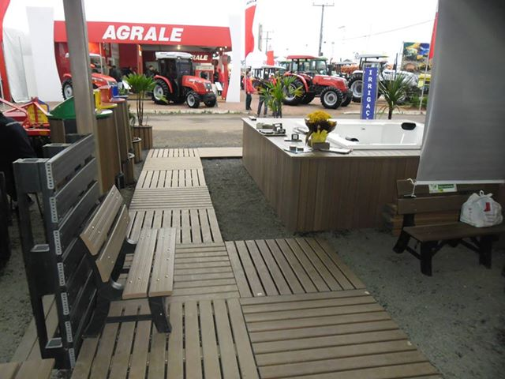](https://www.facebook.com/photo.php?fbid=219505058208298&set=a.129874690504669.28321.129162210575917&type=1&relevant_count=1)



[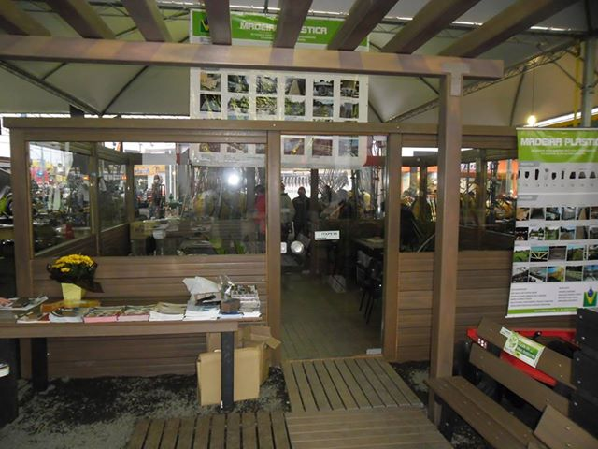](https://www.facebook.com/photo.php?fbid=219504564875014&set=a.129874690504669.28321.129162210575917&type=1&relevant_count=1)

[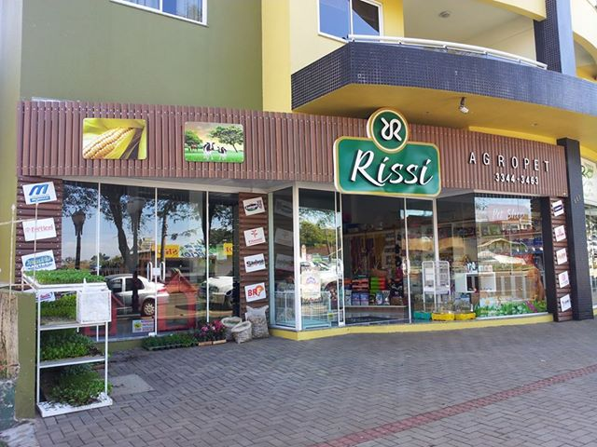](https://www.facebook.com/photo.php?fbid=219218658236938&set=a.129874690504669.28321.129162210575917&type=1&relevant_count=1)



[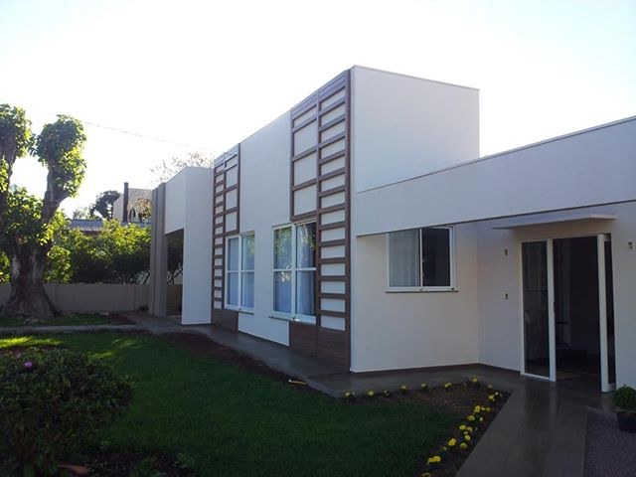](https://www.facebook.com/photo.php?fbid=218965391595598&set=a.129874690504669.28321.129162210575917&type=1&relevant_count=1)

[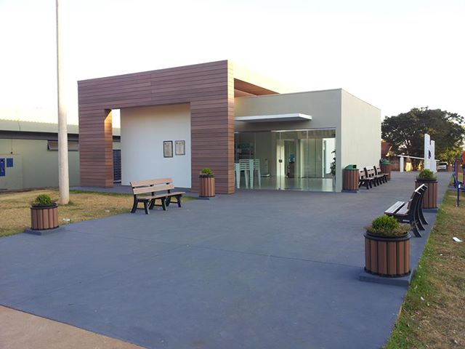](https://www.facebook.com/photo.php?fbid=218689291623208&set=a.129874690504669.28321.129162210575917&type=1&relevant_count=1)



[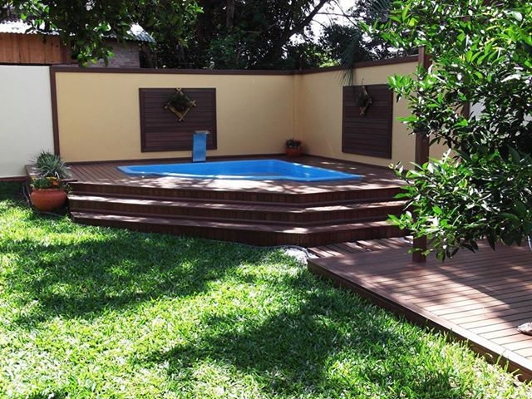](https://www.facebook.com/photo.php?fbid=213120495513421&set=a.129874690504669.28321.129162210575917&type=1&relevant_count=1)

[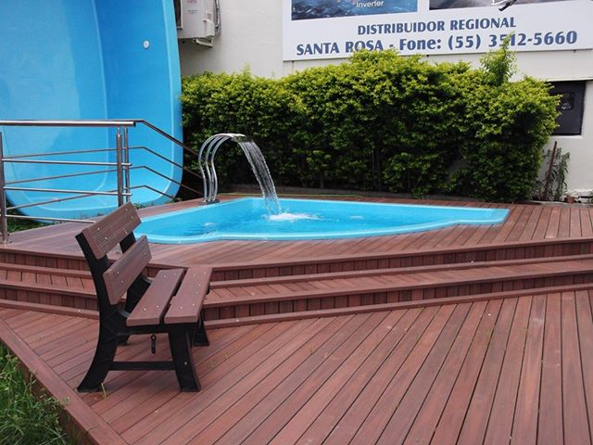](https://www.facebook.com/photo.php?fbid=210179642474173&set=a.129874690504669.28321.129162210575917&type=1&relevant_count=1)



[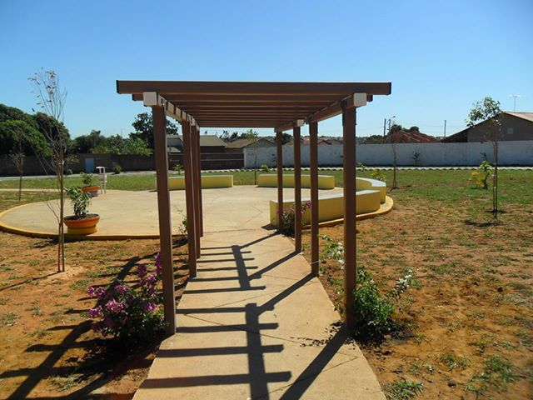](https://www.facebook.com/photo.php?fbid=210178322474305&set=a.129874690504669.28321.129162210575917&type=1&relevant_count=1)

[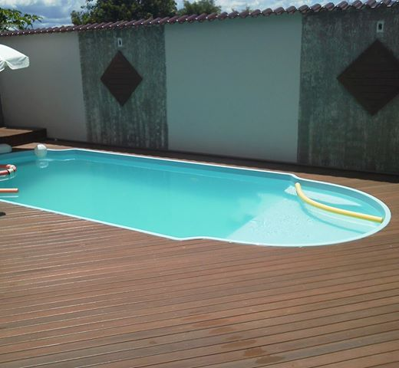](https://www.facebook.com/photo.php?fbid=207684089390395&set=a.129874690504669.28321.129162210575917&type=1&relevant_count=1)



[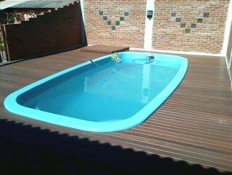](https://www.facebook.com/photo.php?fbid=207679346057536&set=a.129874690504669.28321.129162210575917&type=1&relevant_count=1)

[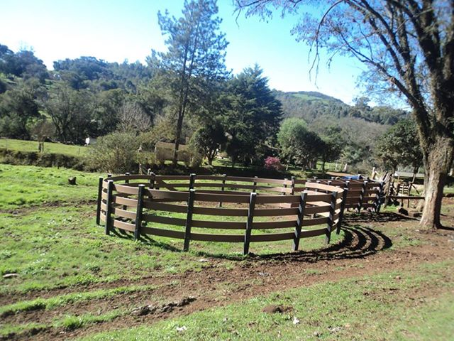](https://www.facebook.com/photo.php?fbid=204687186356752&set=a.129874690504669.28321.129162210575917&type=1&relevant_count=1)



[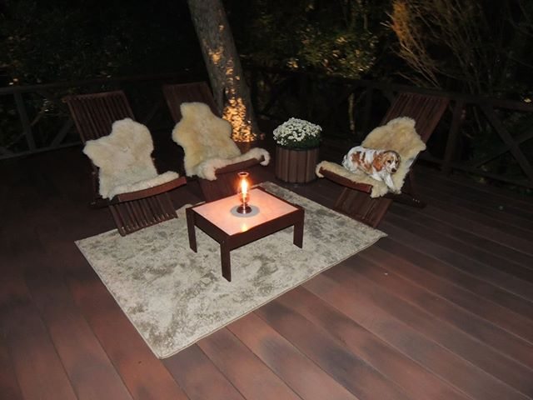](https://www.facebook.com/photo.php?fbid=204115669747237&set=a.129874690504669.28321.129162210575917&type=1&relevant_count=1)

[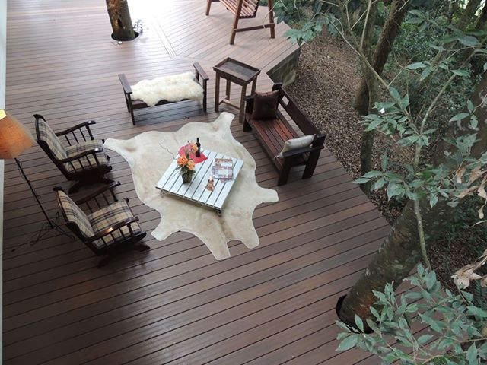](https://www.facebook.com/photo.php?fbid=204116616413809&set=a.129874690504669.28321.129162210575917&type=1&relevant_count=1)



[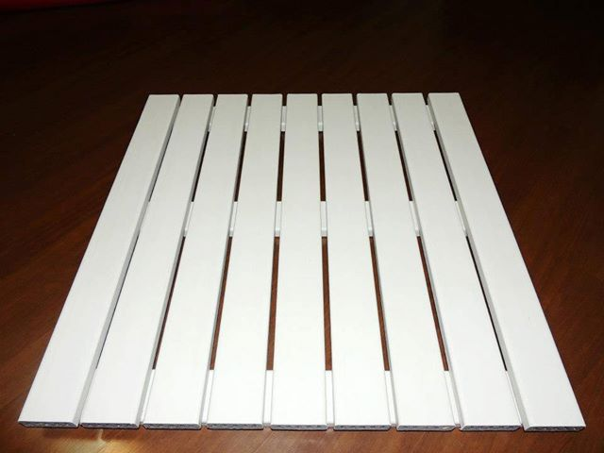](https://www.facebook.com/photo.php?fbid=202797079879096&set=a.129874690504669.28321.129162210575917&type=1&relevant_count=1)

[Foto: Pier de Madeira Plástica InBrasil com mais de 3 anos de instalação
www.piersalvador.com.br](https://www.facebook.com/photo.php?fbid=200082246817246&set=a.129874690504669.28321.129162210575917&type=1&relevant_count=1)



[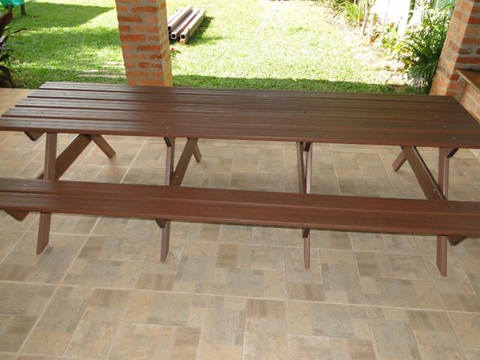](https://www.facebook.com/photo.php?fbid=193958334096304&set=a.129874690504669.28321.129162210575917&type=1&relevant_count=1)

[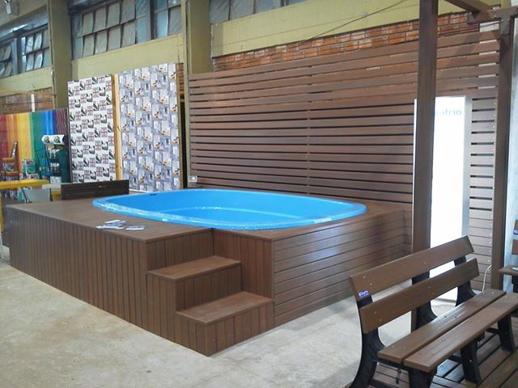](https://www.facebook.com/photo.php?fbid=193957064096431&set=a.129874690504669.28321.129162210575917&type=1&relevant_count=1)



[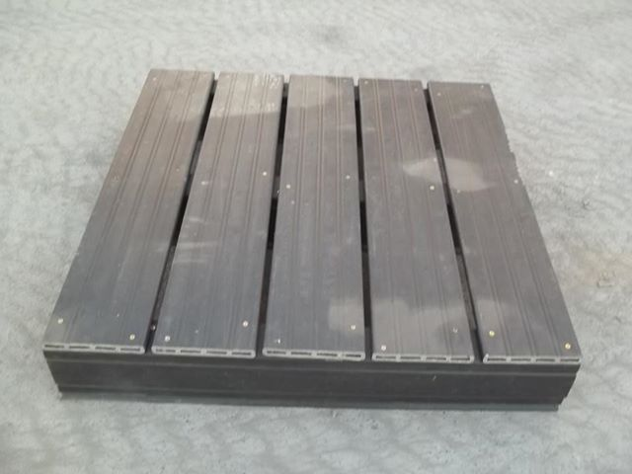](https://www.facebook.com/photo.php?fbid=191582547667216&set=a.129874690504669.28321.129162210575917&type=1&relevant_count=1)

[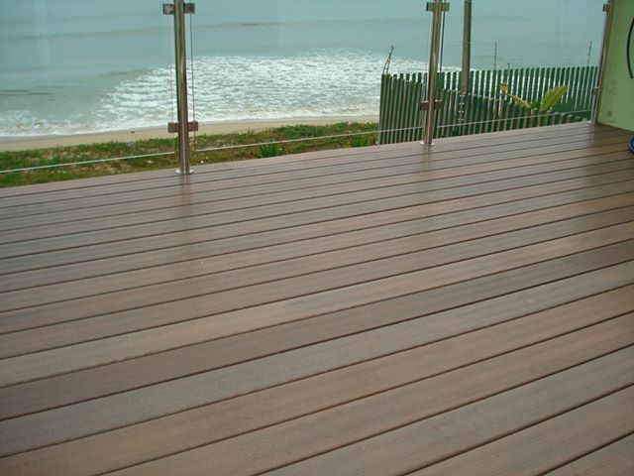](https://www.facebook.com/photo.php?fbid=182582381900566&set=a.129874690504669.28321.129162210575917&type=1&relevant_count=1)



[Foto: Deck de Madeira Plástica InBrasil divulgado na revista Viabiliza.
www.grupoviabiliza.com.br](https://www.facebook.com/photo.php?fbid=185673381591466&set=a.129874690504669.28321.129162210575917&type=1&relevant_count=1)



[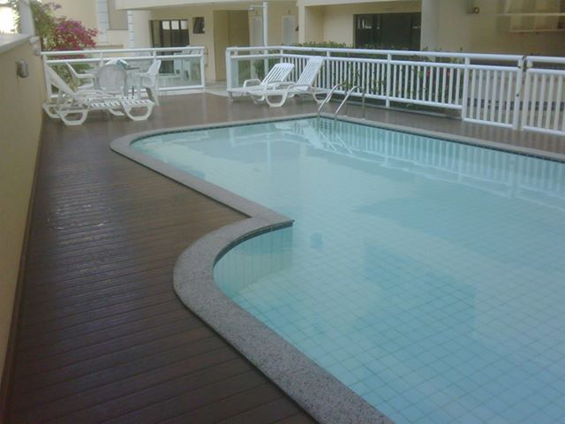](https://www.facebook.com/photo.php?fbid=185512278274243&set=a.129874690504669.28321.129162210575917&type=1&relevant_count=1)

[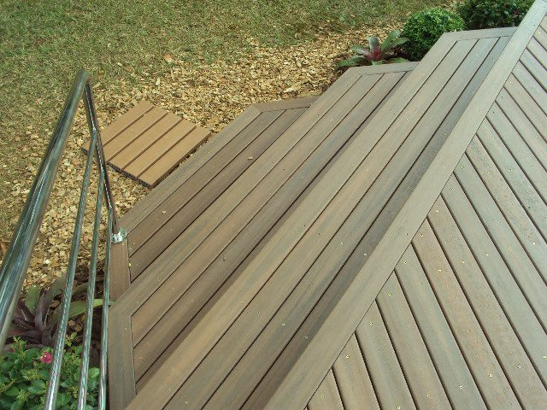](https://www.facebook.com/photo.php?fbid=182581475233990&set=a.129874690504669.28321.129162210575917&type=1&relevant_count=1)



[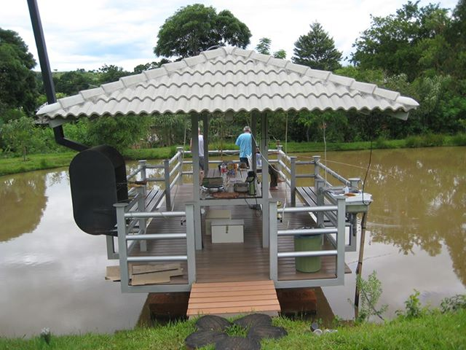](https://www.facebook.com/photo.php?fbid=182037435288394&set=a.129874690504669.28321.129162210575917&type=1&relevant_count=1)

[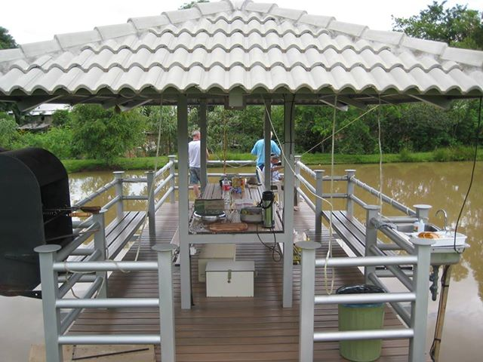](https://www.facebook.com/photo.php?fbid=182036158621855&set=a.129874690504669.28321.129162210575917&type=1&relevant_count=1)



[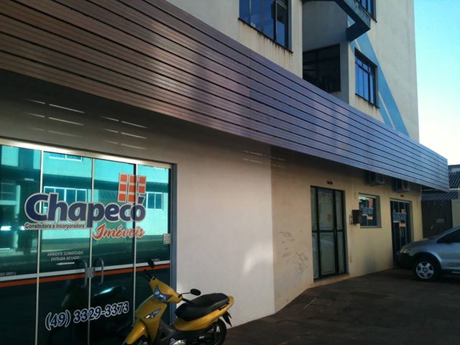](https://www.facebook.com/photo.php?fbid=179700065522131&set=a.129874690504669.28321.129162210575917&type=1&relevant_count=1)

[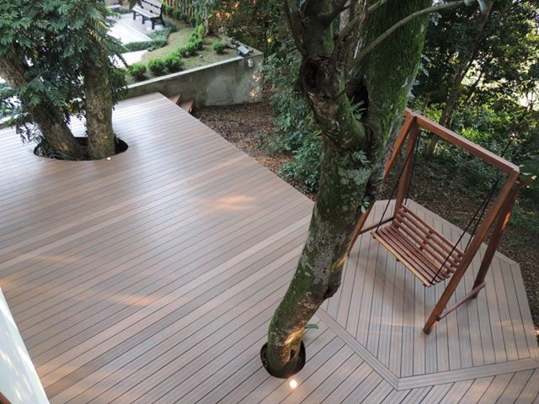](https://www.facebook.com/photo.php?fbid=179105808914890&set=a.129874690504669.28321.129162210575917&type=1&relevant_count=1)



[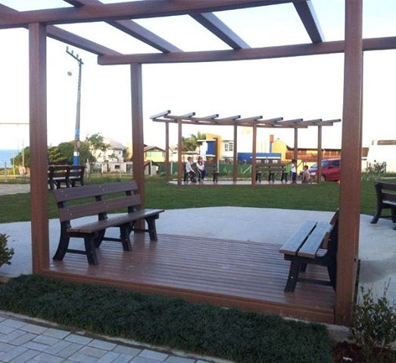](https://www.facebook.com/photo.php?fbid=176971405794997&set=a.129874690504669.28321.129162210575917&type=1&relevant_count=1)

[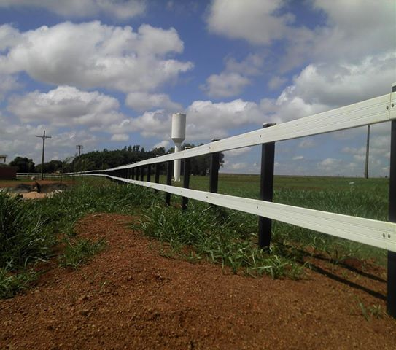](https://www.facebook.com/photo.php?fbid=157492587742879&set=a.129874690504669.28321.129162210575917&type=1&relevant_count=1)



[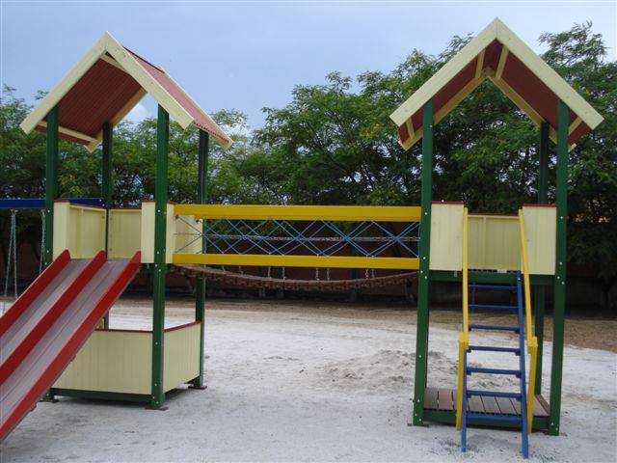](https://www.facebook.com/photo.php?fbid=157490541076417&set=a.157490501076421.1073741829.129162210575917&type=1&relevant_count=4)

[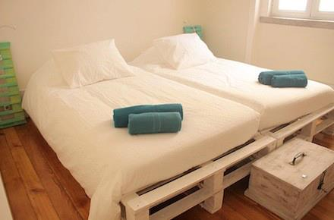](https://www.facebook.com/photo.php?fbid=155329054625899&set=a.155329037959234.1073741825.129162210575917&type=1&relevant_count=4)

[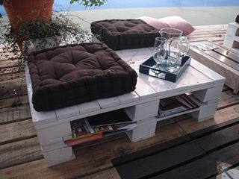](https://www.facebook.com/photo.php?fbid=155329084625896&set=a.155329037959234.1073741825.129162210575917&type=1&relevant_count=3)[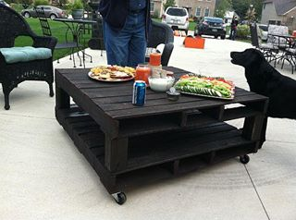](https://www.facebook.com/photo.php?fbid=155329097959228&set=a.155329037959234.1073741825.129162210575917&type=1&relevant_count=2)[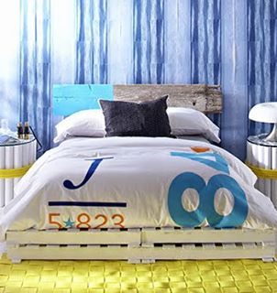](https://www.facebook.com/photo.php?fbid=155329111292560&set=a.155329037959234.1073741825.129162210575917&type=1&relevant_count=1)



[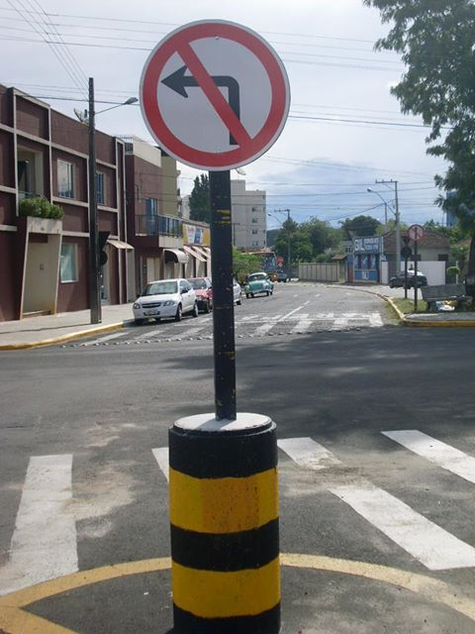](https://www.facebook.com/photo.php?fbid=150233338468804&set=a.129874690504669.28321.129162210575917&type=1&relevant_count=1)



[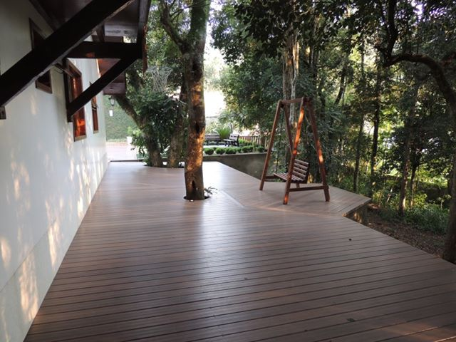](https://www.facebook.com/photo.php?fbid=149916595167145&set=a.129874690504669.28321.129162210575917&type=1&relevant_count=1)

[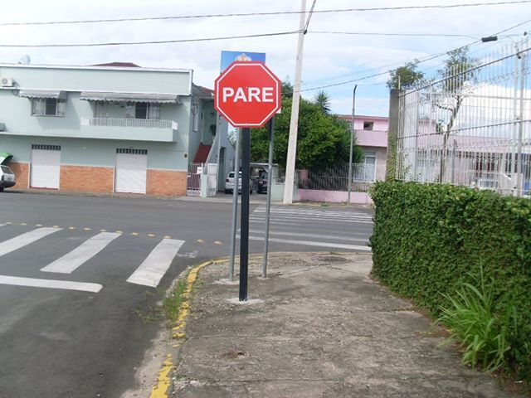](https://www.facebook.com/photo.php?fbid=150232998468838&set=a.129874690504669.28321.129162210575917&type=1&relevant_count=1)



[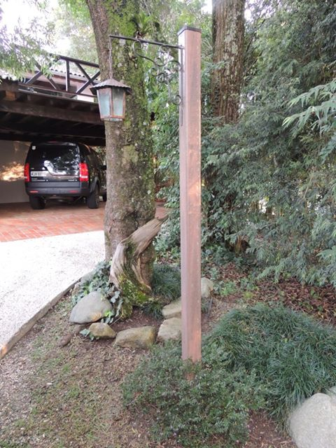](https://www.facebook.com/photo.php?fbid=149915315167273&set=a.129874690504669.28321.129162210575917&type=1&relevant_count=1)



[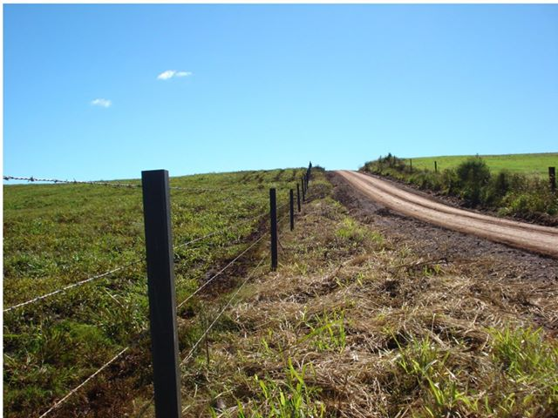](https://www.facebook.com/photo.php?fbid=146345405524264&set=a.129874690504669.28321.129162210575917&type=1&relevant_count=1)[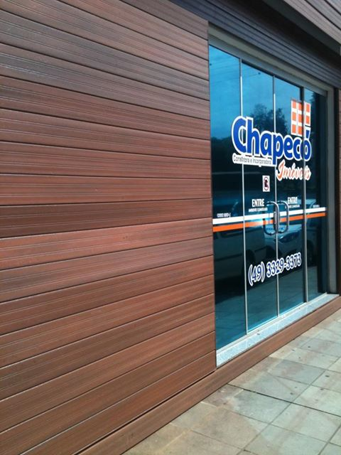](https://www.facebook.com/photo.php?fbid=145791278913010&set=a.129874690504669.28321.129162210575917&type=1&relevant_count=1)



[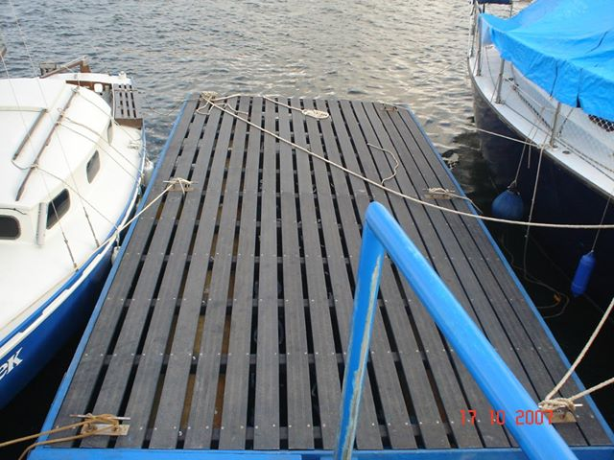](https://www.facebook.com/photo.php?fbid=145785898913548&set=a.129874690504669.28321.129162210575917&type=1&relevant_count=1)

[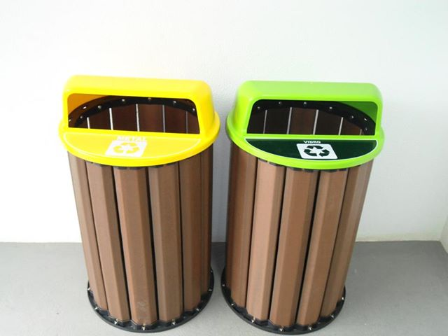](https://www.facebook.com/photo.php?fbid=142731725885632&set=a.129874690504669.28321.129162210575917&type=1&relevant_count=1)



[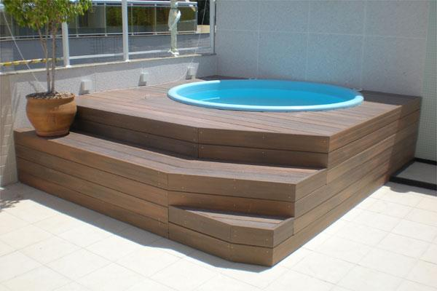](https://www.facebook.com/photo.php?fbid=145785782246893&set=a.129874690504669.28321.129162210575917&type=1&relevant_count=1)

[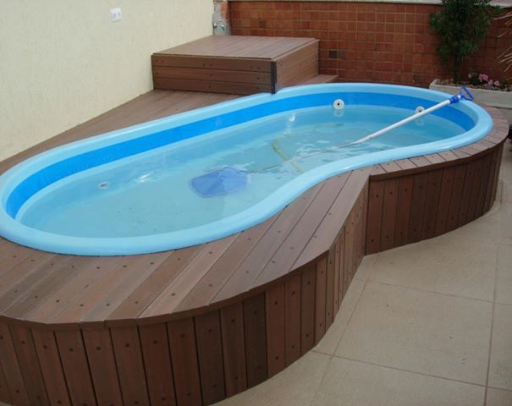](https://www.facebook.com/photo.php?fbid=141454882679983&set=a.129874690504669.28321.129162210575917&type=1&relevant_count=1)



[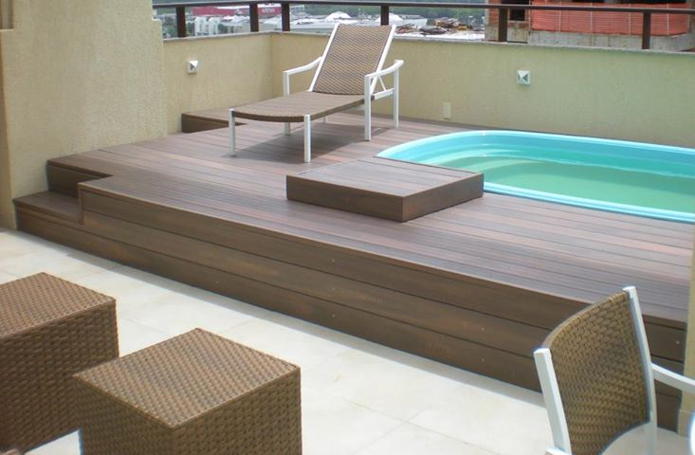](https://www.facebook.com/photo.php?fbid=142727762552695&set=a.129874690504669.28321.129162210575917&type=1&relevant_count=1)

[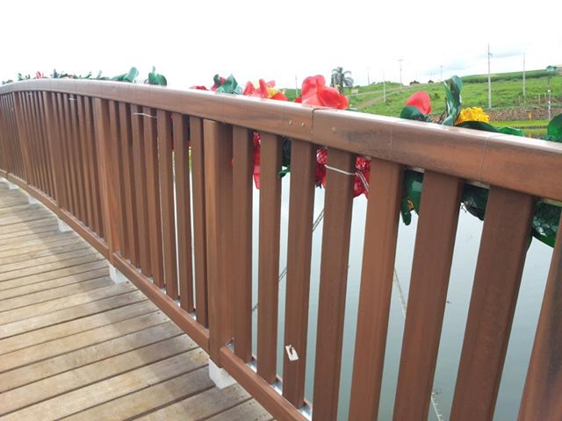](https://www.facebook.com/photo.php?fbid=141165709375567&set=a.129874690504669.28321.129162210575917&type=1&relevant_count=1)



[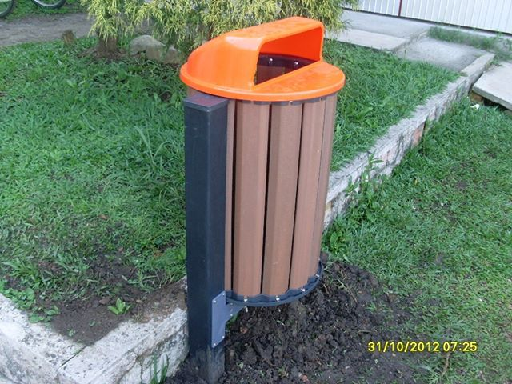](https://www.facebook.com/photo.php?fbid=132320736926731&set=a.129874690504669.28321.129162210575917&type=1&relevant_count=1)

[Foto: A IN-Brasil 
vai estar presente na FEICON 2013
21° Salão Internacional da Construção- FEICON- São Paulo- de 12 a 16 de Março de 2013. Aguardamos sua presença.](https://www.facebook.com/photo.php?fbid=131601626998642&set=a.129874690504669.28321.129162210575917&type=1&relevant_count=1)



[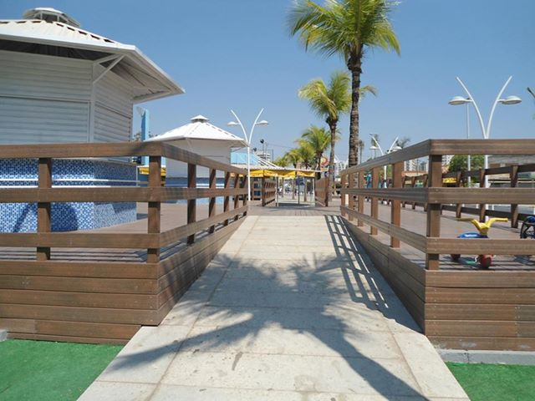](https://www.facebook.com/photo.php?fbid=129875133837958&set=a.129874690504669.28321.129162210575917&type=1&relevant_count=1)

[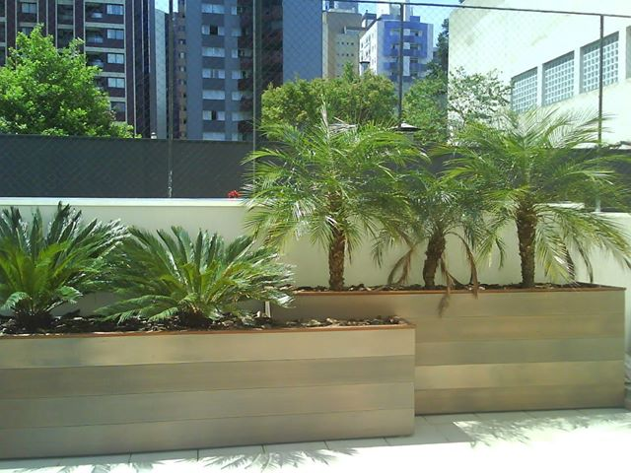](https://www.facebook.com/photo.php?fbid=129874693838002&set=a.129874690504669.28321.129162210575917&type=1&relevant_count=1)



[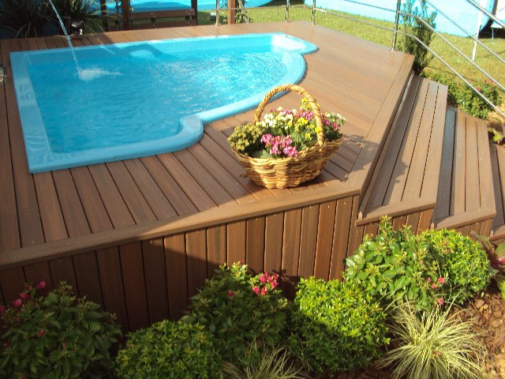](https://www.facebook.com/photo.php?fbid=129257537233051&set=a.129252677233537.28117.129162210575917&type=1)

WWW.ENGEPLAS.COM.BR

41 - 3338 - 7790

engeplas@engeplas.com.br